RULYN - MODERN EDUCATIONAL PLATFORM

PROJECT REPORT
Submitted by
DHARSHAN KUMAR K
(Reg. No: 24BIR007)

HARSHAVARTHAN K S
(Reg. No: 24BIR017)

SANTHOSH S
(Reg. No: 24BIR047)

in partial fulfillment of the requirements for
the award of the degree of
BACHELOR OF SCIENCE
IN
INFORMATION SYSTEMS

DEPARTMENT OF COMPUTER TECHNOLOGY – UG KONGU ENGINEERING COLLEGE
(Autonomous)
PERUNDURAI ERODE – 638 060

MARCH 2026

DEPARTMENT OF COMPUTER TECHNOLOGY-UG KONGU ENGINEERING COLLEGE
(Autonomous)
PERUNDURAI ERODE-638060
MARCH 2026

BONAFIDE CERTIFICATE

This is to certify that the project report titled “RULYN - MODERN EDUCATIONAL PLATFORM” is the approved record of work done by DHARSHAR KUMAR K (Reg. No: 24BIR007),HARSHAVARTHAN K S (Reg. No: 24BIR017) and SANTHOSH S (Reg. No: 24BIR047) in partial fulfilment for the award of Degree of Bachelor of Science in Information Systems of Anna University Chennai during the year 2025-2026.

SUPERVISOR HEAD OF THE DEPARTMENT

(Signature with seal)
Date:
Submitted for the end semester viva-voce examination held on ____________

INTERNAL EXAMINER EXTERNAL EXAMINER

DEPARTMENT OF COMPUTER TECHNOLOGY- UG KONGU ENGINEERING COLLEGE
(Autonomous)
PERUNDURAI ERODE – 638060
MARCH 2026

DECLARATION

We affirm that the project report titled “RULYN – MODERN EDUCATIONAL PLATFORM” being submitted in partial fulfilment of the requirements for the award of B.Sc., Degree in Information Systems is the original work carried out by us. It has not formed the part of any other project submitted for award of any degree, either in this or any other University

DHARSHAR KUMAR K (Reg. No: 24BIR007)

HARSHAVARTHAN K S (Reg. No: 24BIR017)

SANTHOSH S (Reg. No: 24BIR047)

Date:
I certify that the declaration made above by the candidates is true to the best
of my knowledge.
Date: Signature of the Supervisor

ABSTRACT

The main objective of this project is to develop RULYN, a modern educational platform that enhances student learning through gamification, interactive content, and real-time analytics. The platform provides an engaging learning environment where students can read subject-based stories, complete quizzes, earn experience points (XP), unlock achievements, and track their academic progress. By combining storytelling, quizzes, and reward-based learning, the system motivates students to actively participate in their studies while improving understanding and retention. Teachers are also provided with tools to manage learning materials, monitor student performance, and analyze engagement levels effectively.
The system is implemented as a full-stack web application using the MERN stack, which includes MongoDB for database management, Express.js and Node.js for backend development, and React.js for the frontend interface. The frontend is designed to be interactive and responsive, providing features such as student dashboards, progress tracking, quizzes, and gamified learning modules. The backend manages data processing, authentication, content management, and analytics for teachers. The platform also supports communication features, class management, and structured content delivery for different subjects.
This platform improves the learning experience by gamifying education, providing insights into student progress, and simplifying content creation and management for teachers. It creates an interactive digital learning ecosystem that encourages consistent engagement, supports personalized learning journeys, and helps both students and teachers achieve better educational outcomes.

ACKNOWLEDGEMENT

We express our sincere thanks to our beloved Correspondent Thiru. E.R. K. KRISHNAN M.Com., and other philanthropic Trust members of the Kongu Vellalar Institute of Technology Trust for having provided with necessary resources to complete this project.
We are always grateful to our beloved visionary Principal Dr. R. PARAMESHWARAN B.E., M.E., Ph.D., and thank him for his motivation and moral support.
We express our deep sense of gratitude and profound thanks to Dr. S. KALAISELVI M.C.A, M.E, Ph.D., Head of the Department, Computer Technology-UG for her invaluable commitment and guidance for this project.
We are in immense pleasure to express our hearty thanks to our Project Coordinator DR.S.TAMILSELVI M.C.A., M.Phil., Ph.D., and our project guide Dr. N.T. RENUKADEVI M.C.A., M.Phil., Ph.D., for providing valuable guidance and constant support throughout our project.
We also thank the teaching, and non-teaching staff members, fellow students, and our parents who stood with us to complete our project successfully.

TABLE OF CONTENTS

CHAPTER No. | TITLE | PAGE No.
 | ABSTRACT | iii
1 | INTRODUCTION  1.1 Problem  1.2 Objective | 1  2
2 | LITERATURE SURVEY | 5
3 | SYSTEM SPECIFICATION  3.1 Introduction  3.2 Software Specification  3.3 Hardware Specification  3.4 System Architecture Overview | 8  8  9  9
4 | DATASET AND METHODOLOGY  4.1 Dataset Description  4.2 Methodology | 11  12
5 | EVALUATION METRICS & RESULT ANALYSIS  5.1 Evaluation Metrics Used  5.2 Result Analysis | 17  19
6 | CONCLUSION AND FUTURE WORK  6.1 Conclusion  6.2 Future Work | 22  23
 | APPENDIX 1 (coding) | 25
 | APPENDIX 2 (images) | 50
7 | REFERENCES | 54

CHAPTER 1
INTRODUCTION

1.1 Problem
In many rural schools, students studying STEM subjects face significant challenges in maintaining interest and engagement due to traditional teaching methods that rely heavily on textbooks and lectures. These approaches often lack interactive elements, making it difficult for students to visualize complex concepts in subjects such as science and mathematics. As a result, students tend to lose motivation, which affects their understanding and academic performance. The absence of engaging learning tools and gamified educational content further limits the effectiveness of STEM education in rural environments.
Another major issue is the limited availability of reliable internet connectivity in rural regions. Most modern digital learning platforms depend on continuous high-speed internet access to stream videos, load interactive content, or access cloud-based resources. However, many rural areas experience unstable or slow internet connections, making these platforms difficult or impossible to use consistently. Because of this limitation, students are often unable to benefit from the advantages of modern e-learning technologies that are commonly available to urban learners.
Language accessibility also presents a critical barrier. A large number of rural students are more comfortable learning in their regional languages rather than English. However, many existing educational platforms provide learning materials primarily in English and lack adequate support for regional language explanations or audio-based guidance. This makes it difficult for students to fully understand educational content, especially in technical subjects, which can reduce their confidence and willingness to continue learning.
In addition to student-related challenges, teachers in rural schools often lack access to digital tools that help monitor student progress and engagement. Traditional evaluation methods mainly rely on written examinations or manual record keeping, which do not provide real-time insights into how students are learning or which topics they find difficult. Without proper analytics or tracking systems, teachers cannot easily identify struggling students or adapt their teaching methods accordingly.
Limited access to affordable digital devices and educational technology infrastructure further complicates the situation. Many schools do not have sufficient digital resources, and teachers may not have platforms that allow them to easily create interactive content, assign quizzes, or track learning outcomes. This results in a significant gap between modern digital education systems and the resources available in rural schools.
Therefore, the core problem is not only the lack of digital learning platforms, but the absence of a low-cost, accessible, interactive, and teacher-supported educational system that can function effectively in rural environments. An effective solution should be able to:
- Increase student engagement in STEM subjects through interactive and gamified learning
- Function efficiently even in low-bandwidth or limited connectivity environments
- Support learning through simple and accessible digital interfaces
- Provide teachers with analytics tools to track student progress and engagement
- Improve accessibility for rural learners and support modern digital education practices
Addressing these challenges is the primary motivation behind developing RULYN – a Modern Educational Platform designed to enhance engagement, accessibility, and learning outcomes for students while providing teachers with effective tools to manage and analyze the learning process.
1.2 Objective
The primary objective of this project is to design and develop RULYN, a modern educational platform that enhances student engagement in STEM learning through interactive and gamified digital experiences. The system aims to transform traditional learning methods by introducing story-based learning modules, quizzes, achievements, and progress tracking that motivate students to actively participate in the learning process. By making education more interactive and rewarding, the platform encourages students to develop stronger interest and understanding in subjects such as science and mathematics.
Another important objective is to provide an accessible digital learning environment for students in rural and resource-limited areas. Many existing online learning platforms require high-speed internet and advanced devices, making them difficult to use in rural schools. The proposed platform is designed to function efficiently with simple digital interfaces and optimized content delivery, ensuring that students with limited connectivity and low-cost devices can still benefit from modern digital learning tools.
The system also aims to support teachers by providing tools for content creation, class management, and student performance analysis. Teachers can create educational stories, quizzes, and assignments that align with the curriculum and assign them to students through the platform. In addition, the system provides analytics dashboards that help educators track student engagement, monitor quiz performance, and identify learning gaps. These insights allow teachers to provide more targeted guidance and improve overall learning outcomes.
A key objective of the project is to promote continuous learning and motivation through gamification elements such as experience points (XP), levels, achievements, and progress tracking. By incorporating reward-based learning mechanisms, the platform encourages students to regularly participate in learning activities and build consistent study habits.
Furthermore, the system aims to bridge the gap between traditional classroom teaching and modern digital education by creating a centralized platform where students can learn interactively while teachers can efficiently manage educational content and monitor learning progress.
In summary, the objectives of the proposed system are to:
- Design and develop an interactive educational platform that improves student engagement in STEM learning.
- Introduce gamified learning features such as quizzes, achievements, and progress tracking to motivate students.
- Provide teachers with tools to create learning content and monitor student performance through analytics.
- Develop a user-friendly digital platform accessible to students with limited technological resources.
- Support modern digital education practices by combining interactive learning with effective content management.
These objectives directly address the challenges identified in Smart India Hackathon (SIH) Problem Statement 25009, which focuses on improving accessibility, engagement, and effectiveness of digital education systems, particularly for students in rural and resource-constrained learning environments.

CHAPTER 2

LITERATURE SURVEY
The rapid growth of digital technology has greatly influenced the education sector. Modern learning systems now use interactive platforms, gamification, and data analysis to improve teaching and learning. Digital learning platforms allow students to access study materials, complete quizzes, and track their progress online. These platforms also help teachers monitor student performance and manage learning content more effectively. As a result, educational technology has become an important tool for improving student engagement and supporting personalized learning.
Gamified learning platforms combine education with game-like elements such as rewards, achievements, levels, and progress tracking. These features motivate students and encourage them to participate more actively in learning activities. Studies show that students remain more engaged and perform better when learning includes interactive and reward-based systems. Gamified platforms can also adjust learning content based on the student’s progress and understanding.

2.1 Digital Learning Platforms in Education
Several studies show that digital learning platforms play an important role in modern education. These platforms provide a centralized system where students can access study materials, take quizzes, and interact with teachers. They also help institutions organize educational content in a structured way and allow students to learn beyond the traditional classroom environment.
However, many existing learning platforms mainly provide static materials such as video lectures or documents. These resources often lack interactive features that encourage active student participation. In addition, students in rural or resource-limited areas may face difficulties accessing such platforms due to poor infrastructure or limited internet connectivity. Therefore, there is a need for simple and interactive learning systems that are accessible to a wider group of students.

2.2 Gamification in Educational Systems
Gamification refers to the use of game design elements in non-game environments such as education. Studies in educational technology show that gamified learning improves student motivation, participation, and knowledge retention. By integrating elements commonly found in games, learning platforms can make educational activities more engaging and enjoyable for students.
Modern gamified learning platforms allow educational systems to:
- Reward students with experience points (XP) for completing tasks
- Introduce levels and achievements to motivate progress
- Provide quizzes and challenges to test understanding
- Track learning progress through visual dashboards
Gamified systems also provide instant feedback through quizzes and interactive activities, helping students identify their strengths and weaknesses quickly. Research indicates that incorporating game-based learning strategies significantly increases student engagement and encourages continuous learning.

2.3 Learning Analytics and Student Performance Tracking
Learning analytics is an important feature of modern educational platforms. It involves collecting and analyzing student data to understand learning patterns, engagement, and academic performance. Analytics tools help teachers monitor student progress and identify areas where students may need additional support.
Using dashboards and visual reports, teachers can track quiz results, participation in activities, and overall learning progress. However, many existing educational systems do not provide proper analytics tools, and student performance is often measured only through periodic exams, which do not give real-time insights into student learning behavior.

2.4 Research Gap
From the literature review, several limitations in existing educational platforms can be identified:
- Many digital learning systems lack interactive and gamified learning features that maintain student engagement.
- Traditional teaching methods often rely on passive learning materials rather than interactive educational experiences.
- Some platforms do not provide effective analytics tools for teachers to monitor student progress and learning patterns.
- Educational systems designed for large-scale environments may not always be suitable for students with limited digital resources.
The proposed RULYN – Modern Educational Platform aims to address these challenges by integrating gamified learning modules, interactive quizzes, achievement systems, and analytics dashboards for teachers. By combining engaging learning methods with effective content management and progress tracking, the system provides an improved digital learning environment for both students and educators.

CHAPTER 3
SYSTEM SPECIFICATION

3.1 Introduction
The proposed RULYN – Modern Educational Platform is designed to create an interactive digital learning environment for students and teachers. The system improves student engagement in STEM subjects through gamified features such as quizzes, achievements, and progress tracking. It is developed using a full-stack architecture with React.js for the frontend, Node.js and Express.js for the backend, and MySQL for database management, making the platform efficient, scalable, and suitable for modern digital learning.

3.2 Software Specification

3.2.1. Frontend Technology
The frontend of the system is developed using React.js. React.js is used to build a dynamic and responsive user interface that allows students and teachers to interact with the platform easily. It provides a component-based architecture, fast rendering using the Virtual DOM, and a smooth user experience across different devices. The frontend includes features such as student dashboards, quizzes, progress tracking, and teacher management interfaces.

3.2.2. Backend Technology
The backend of the system is developed using Node.js and Express.js. These technologies handle server-side logic, API requests, authentication, and communication between the frontend and the database. The backend manages important operations such as:
- User authentication and profile management
- Quiz management and submissions
- Student progress tracking
- Content management for teachers
Node.js and Express.js provide a fast, scalable, and efficient server environment for handling application requests.

3.2.3. Database Technology
The database is implemented using MySQL, a relational database management system used to store and manage application data. It stores information such as:
- Student and teacher account details
- Learning content and educational stories
- Quiz questions and results
- Student progress and achievements
MySQL provides structured data storage, reliable performance, and efficient data retrieval, making it suitable for educational applications.

3.3 Hardware Specification
The system requires minimal hardware resources for development and deployment:
- Processor: Intel i3 or higher
- RAM: Minimum 4 GB
- Storage: 20 GB free space
- Internet: Required for accessing the web application

3.4 System Architecture Overview
The system follows a three-layer architecture:
- Presentation Layer – React.js based user interface for students and teachers.
- Application Layer – Node.js and Express.js backend that processes requests and manages application logic.
- Data Layer – MySQL database used to store and manage application data.
Users interact with the frontend interface, which sends requests to the backend server. The backend processes the request, retrieves or updates data from the database, and sends the appropriate response back to the user interface.

CHAPTER 4
DATASET AND METHODOLOGY

4.1 Dataset Description

4.1.1 Dataset Source
The dataset used in the RULYN educational platform is collected from educational learning materials and teacher-created content. The dataset includes information related to:
- Subject-based learning stories
- Quiz questions and answers
- Student profile and progress data
- Achievement and reward system data
- Teacher-generated educational content
Teachers can create and manage learning content through the platform, ensuring that students always access updated educational material.

4.1.2 Educational Content Dataset
The platform uses structured educational datasets to support interactive learning. The dataset mainly contains:
- Learning stories for different subjects
- Quiz questions for knowledge assessment
- Correct answers and explanations
- Achievement and reward rules for gamification
This dataset helps the system deliver engaging learning content and evaluate student understanding through quizzes and progress tracking.

4.1.3 Dataset Updating Mechanism
The platform supports dynamic dataset updates through the teacher interface.
- Teachers create or update learning stories and quizzes.
- The content is stored in the MySQL database.
- The platform automatically reflects updated content for students.
This mechanism ensures that students always receive the latest learning materials without requiring system reconfiguration.

4.2 Methodology

4.2.1 Development Methodology
The project follows the Agile development methodology, which supports step-by-step development and continuous improvement. Instead of developing the entire system at once, the platform is built in small modules and tested regularly.
The development phases include:
- Requirement Analysis
- System Design
- Frontend Development
- Backend Development
- Database Integration
- Gamification Feature Implementation
- Testing and Validation
The Agile model helps in:
- Continuous testing and debugging
- Easy modification of system features
- Faster development and improvements
- Better system reliability

4.2.2 System Design Methodology
The system is designed using a modular architecture consisting of the following modules:
- Student Interface Module
- Teacher Management Module
- Quiz and Learning Module
- Progress Tracking and Analytics Module
- Database Management Module
Each module performs a specific task and interacts with other modules to ensure smooth system functionality.

4.2.3 Gamified Learning Methodology
The platform uses gamification techniques to improve student engagement and motivation.
The gamification process includes:
- Awarding experience points (XP) for completing quizzes
- Providing achievements and badges for milestones
- Tracking student progress through levels
- Encouraging continuous learning through rewards
These features motivate students to actively participate in learning activities and maintain consistent engagement.

4.2.4 Frontend Development Methodology
The frontend is developed using React.js.
The methodology includes:
- Component-based architecture
- Dynamic message rendering
- State management for real-time updates
- Responsive interface design
React ensures smooth interaction and quick updates without reloading pages.

4.2.5 Database Management Methodology
The system uses MySQL as the database to store and manage application data.
Data Handling Process:
- Store student and teacher account information.
- Store learning content and quizzes.
- Track student progress and achievements.
- Retrieve and update data when users interact with the system.
MySQL provides reliable and structured data storage for the educational platform.

4.2.6 Teacher-Based Content Management
Teachers can manage learning content through the platform.
Process:
- Teacher logs into the system.
- Teacher creates or updates learning stories and quizzes.
- The data is stored in the MySQL database.
- Students can access the updated content through the platform.
This system allows teachers to easily manage and update learning materials.

4.2.7 System Integration Methodology
The system follows a structured integration process:
- Student accesses the platform through the frontend interface.
- The request is sent to the backend server.
- The backend processes the request using Node.js and Express.js.
- The required data is retrieved from the MySQL database.
- The response is sent back to the frontend and displayed to the user.
This integration ensures smooth communication between the frontend, backend, and database components of the system.

CHAPTER 5

EVALUATION METRICS & RESULT ANALYSIS

Evaluation Metrics and Result Analysis are used to measure the performance, effectiveness, and usability of the RULYN educational platform. Since the system is designed to improve student engagement through gamified learning and interactive quizzes, it is important to evaluate how effectively the platform supports learning activities, tracks student progress, and maintains system performance.
The evaluation process ensures that the platform meets its objectives such as improving student participation, providing accurate progress tracking, and helping teachers monitor learning outcomes effectively.

5.1 Evaluation Metrices Used

5.1.1 Quiz Performance Accuracy
Quiz Performance Accuracy measures how effectively the platform evaluates student knowledge through quizzes.
The system records quiz attempts and calculates the student’s performance based on correct answers.
Quiz Accuracy is calculated as:
Accuracy = (Correct Answers / Total Questions) × 100
This metric helps determine how well students understand the learning content provided by the platform.

5.1.2. Student Engagement Level
Student Engagement Level measures how actively students participate in the learning activities available on the platform.
This metric considers factors such as:
- Number of quizzes attempted
- Frequency of platform usage
- Completion of learning stories
- Achievement badges earned
Higher engagement levels indicate that the gamification features are effectively motivating students to continue learning.

5.1.3. Response Time
System Response Time measures how quickly the platform responds to user actions such as loading content, submitting quizzes, or retrieving student progress.
Response Time is calculated as:
Response Time = Time of Response – Time of Request
The system uses React.js for fast frontend rendering and Node.js backend processing with MySQL database, ensuring quick data retrieval and smooth user interaction.
Low response time improves overall user experience.

5.1.4. Learning Progress Tracking
Learning Progress Tracking measures how effectively the system records and displays student progress.
The platform tracks:
- Quiz scores
- Learning levels
- Experience points (XP)
- Achievements earned
These indicators help both students and teachers monitor academic improvement over time.

5.1.5. Teacher Analytics Effectiveness
Teacher Analytics evaluates how useful the platform is for teachers to monitor student performance.
Through dashboards and reports, teachers can:
- Track student quiz performance
- Monitor engagement levels
- Identify students who need additional support
This helps teachers make better decisions regarding teaching strategies.

5.2 Result Analysis
After testing the RULYN platform with multiple users, the following results were observed:
Improved Student Engagement
Students showed increased participation in learning activities due to gamified features such as quizzes, experience points, and achievements.
Accurate Learning Assessment
The quiz system successfully evaluated student understanding and provided immediate feedback on their performance.
Fast System Performance
The platform responded quickly to user actions due to the efficient integration of React.js frontend, Node.js backend, and MySQL database.
Effective Progress Monitoring
Teachers were able to monitor student progress through analytics dashboards and identify learning gaps more easily.
Enhanced Learning Experience
The interactive learning approach made education more engaging compared to traditional static learning methods.

CHAPTER-6

CONCLUSION AND FUTURE ENHANCEMENT

6.1 Conclusion
The proposed RULYN – Modern Educational Platform was developed to improve student engagement and make learning more interactive through gamified educational methods. The platform provides an engaging environment where students can read learning content, attempt quizzes, earn experience points (XP), unlock achievements, and track their academic progress. By combining educational materials with gamification features, the system encourages students to participate actively in the learning process.
The platform is implemented using React.js for the frontend, Node.js and Express.js for backend development, and MySQL for database management. This architecture ensures efficient data handling, smooth user interaction, and reliable system performance. Teachers can create learning content, manage quizzes, and monitor student progress through analytics dashboards, which helps them better understand student performance and provide appropriate guidance.
From the evaluation results, it is clear that:
- The platform improves student engagement through gamified learning features.
- It provides accurate assessment of student knowledge through quizzes.
- Teachers can easily monitor student progress and performance.
- The system provides fast and smooth interaction through a modern web interface.
- It supports an interactive and structured digital learning environment.
Overall, the RULYN platform successfully enhances the learning experience for students while providing teachers with effective tools to manage and analyze educational content.

6.2 Future Enhancement
Although the current system performs effectively, several improvements can be implemented in the future to enhance its capabilities:
- Mobile Application Development
A dedicated mobile application for Android and iOS can be developed to make the platform more accessible for students.
- AI-Based Personalized Learning
Artificial Intelligence can be integrated to recommend personalized learning content based on student performance and learning patterns.
- Advanced Learning Analytics
More advanced analytics tools can be introduced to provide deeper insights into student behavior and learning progress.
- Multimedia Learning Content
Future versions can include video lessons, animations, and interactive simulations to improve understanding of complex topics.
- Offline Learning Support
The system can be enhanced to support limited offline access, allowing students in low-connectivity areas to continue learning.
- Integration with School Management Systems
The platform can be integrated with existing school or college management systems to provide additional academic information such as attendance and exam results.
These improvements can further enhance the effectiveness of the RULYN platform and support the development of a more advanced digital learning environment.

APPENDIX 1

CODING
App.js
import React, { useState, useEffect } from "react";
import "./App.css";
import studentImg from "./student1.jpg";

/* ================= USER SIGNUP ================= */
function Signup({ onSignup, switchToLogin }) {
const [name, setName] = useState("");
const [email, setEmail] = useState("");
const [password, setPassword] = useState("");

const handleSubmit = async (e) => {
e.preventDefault();
try {
const res = await fetch("http://localhost:5000/api/auth/signup", {
method: "POST",
headers: { "Content-Type": "application/json" },
body: JSON.stringify({ name, email, password, role: "user" }),
});
const data = await res.json();
if (res.ok) {
alert(data.message);
onSignup();
} else {
alert(data.message);
}
} catch (err) {
console.error(err);
alert("Signup failed");
}
};

return (
<div className="auth-wrapper">
<div className="bg-white p-8 rounded-xl shadow-md w-80">
<h2>User Sign Up</h2>
<form onSubmit={handleSubmit}>
<input placeholder="Name" value={name} onChange={(e) => setName(e.target.value)} />
<input placeholder="Email" value={email} onChange={(e) => setEmail(e.target.value)} />
<input type="password" placeholder="Password" value={password} onChange={(e) => setPassword(e.target.value)} />
<button className="bg-green-500">Sign Up</button>
</form>
<p><button onClick={switchToLogin}>Login</button></p>
</div>
</div>
);
}

/* ================= ADMIN SIGNUP ================= */
function AdminSignup({ onSignup, switchToLogin }) {
const [name, setName] = useState("");
const [email, setEmail] = useState("");
const [password, setPassword] = useState("");

const handleSubmit = async (e) => {
e.preventDefault();
try {
const res = await fetch("http://localhost:5000/api/auth/signup", {
method: "POST",
headers: { "Content-Type": "application/json" },
body: JSON.stringify({ name, email, password, role: "admin" }),
});
const data = await res.json();
if (res.ok) {
alert(data.message);
onSignup();
} else {
alert(data.message);
}
} catch (err) {
console.error(err);
alert("Admin signup failed");
}
};

return (
<div className="admin-auth-wrapper">
<div className="admin-card">
<h2>Admin Sign Up</h2>
<form onSubmit={handleSubmit}>
<input placeholder="Name" value={name} onChange={(e) => setName(e.target.value)} />
<input placeholder="Email" value={email} onChange={(e) => setEmail(e.target.value)} />
<input type="password" placeholder="Password" value={password} onChange={(e) => setPassword(e.target.value)} />
<button className="admin-btn">Sign Up</button>
</form>
<button onClick={switchToLogin}>Login</button>
</div>
</div>
);
}

/* ================= LOGIN ================= */
function Login({ onLogin, switchToSignup, switchToAdminSignup }) {
const [email, setEmail] = useState("");
const [password, setPassword] = useState("");
const [role, setRole] = useState("user");

const handleSubmit = async (e) => {
e.preventDefault();
try {
const res = await fetch("http://localhost:5000/api/auth/login", {
method: "POST",
headers: { "Content-Type": "application/json" },
body: JSON.stringify({ email, password, role }),
});
const data = await res.json();
if (res.ok) {
localStorage.setItem("token", data.token);
localStorage.setItem("loggedUser", JSON.stringify(data.user));
onLogin(data.user);
} else {
alert(data.message);
}
} catch (err) {
console.error(err);
alert("Login failed");
}
};

return (
<div className="auth-wrapper">
<div className="bg-white p-8 rounded-xl shadow-md w-96">
<h2>Login</h2>
<form onSubmit={handleSubmit}>
<select value={role} onChange={(e) => setRole(e.target.value)}>
<option value="user">User</option>
<option value="admin">Admin</option>
</select>
<input placeholder="Email" value={email} onChange={(e) => setEmail(e.target.value)} />
<input type="password" placeholder="Password" value={password} onChange={(e) => setPassword(e.target.value)} />
<button className="bg-blue-500">Login</button>
</form>

<p><button onClick={switchToSignup}>User Sign Up</button></p>
<p><button onClick={switchToAdminSignup}>Admin Sign Up</button></p>
</div>
</div>
);
}

/* ================= ADMIN DASHBOARD ================= */
function AdminDashboard({ onLogout }) {
const [users, setUsers] = useState([]);
const [loading, setLoading] = useState(true);
const [newUser, setNewUser] = useState({
name: "",
email: "",
password: "",
role: "user",
});
const addUser = async () => {
if (!newUser.name || !newUser.email || !newUser.password) {
alert("Fill all fields");
return;
}

try {
const res = await fetch("http://localhost:5000/api/users", {
method: "POST",
headers: { "Content-Type": "application/json" },
body: JSON.stringify(newUser),
});

const data = await res.json();

if (res.ok) {
alert(data.message);
setNewUser({ name: "", email: "", password: "", role: "user" });
fetchUsers(); // refresh table
} else {
alert(data.message);
}
} catch (err) {
console.error(err);
alert("Add user failed");
}
};

const fetchUsers = async () => {
try {
const res = await fetch("http://localhost:5000/api/users"); // add this endpoint in server.js
const data = await res.json();
setUsers(data);
setLoading(false);
} catch (err) {
console.error(err);
alert("Failed to fetch users");
}
};

const deleteUser = async (id) => {
if (!window.confirm("Are you sure you want to delete?")) return;

try {
const res = await fetch(
`http://localhost:5000/api/users/${id}`,
{ method: "DELETE" }
);

const data = await res.json();

if (res.ok) {
alert(data.message);
fetchUsers(); // refresh list
} else {
alert(data.message);
}
} catch (err) {
console.error(err);
alert("Delete failed");
}
};

useEffect(() => {
fetchUsers();
}, []);

return (

<div className="admin-dashboard">
<h1>Admin Dashboard</h1>
{loading ? (
<p>Loading users...</p>
) : (
<>
<div className="admin-add-user">
<h3>Add User</h3>

<input
placeholder="Name"
value={newUser.name}
onChange={(e) => setNewUser({ ...newUser, name: e.target.value })}
/>

<input
placeholder="Email"
value={newUser.email}
onChange={(e) => setNewUser({ ...newUser, email: e.target.value })}
/>

<input
type="password"
placeholder="Password"
value={newUser.password}
onChange={(e) => setNewUser({ ...newUser, password: e.target.value })}
/>

<select
value={newUser.role}
onChange={(e) => setNewUser({ ...newUser, role: e.target.value })}
>
<option value="user">User</option>
<option value="admin">Admin</option>
</select>

<button className="admin-btn" onClick={addUser}>
Add
</button>
</div>

<table>
<thead>
<tr>
<th>Name</th>
<th>Email</th>
<th>Role</th>
<th>Action</th>
</tr>
</thead>

<tbody>
{users.map((u) => (
<tr key={u._id}>
<td>{u.name}</td>
<td>{u.email}</td>
<td>{u.role}</td>
<td>
<button
className="bg-red-500"
onClick={() => deleteUser(u._id)}
>
Delete
</button>
</td>
</tr>
))}
</tbody>
</table>
</>
)}
<button className="Admin_logout" onClick={onLogout}>Logout</button>
</div>

);
}

/* ================= MAIN APP ================= */
function App() {
const [user, setUser] = useState(null);
const [showSignup, setShowSignup] = useState(false);
const [showAdminSignup, setShowAdminSignup] = useState(false);

useEffect(() => {
const storedUser = localStorage.getItem("loggedUser");
if (storedUser) setUser(JSON.parse(storedUser));
}, []);

const loginUser = (u) => setUser(u);
const logoutUser = () => {
setUser(null);
localStorage.removeItem("loggedUser");
localStorage.removeItem("token");
};

if (!user) {
if (showSignup) return <Signup onSignup={() => setShowSignup(false)} switchToLogin={() => setShowSignup(false)} />;
if (showAdminSignup) return <AdminSignup onSignup={() => setShowAdminSignup(false)} switchToLogin={() => setShowAdminSignup(false)} />;
return <Login onLogin={loginUser} switchToSignup={() => setShowSignup(true)} switchToAdminSignup={() => setShowAdminSignup(true)} />;
}

if (user.role === "admin") return <AdminDashboard onLogout={logoutUser} />;

return (
<div className="app-wrapper">
<header className="app-header">
<div className="header-inner">
<h1 className="main-title">Kongu Buddy</h1>
<p className="tagline">Instant Help • Any Language • 24/7</p>
</div>
</header>

<main className="chat-area">
<div className="chat-card">
<div className="chat-header">
<img src={studentImg} alt="student" className="chat-image" />
<div>
<h2 className="chat-title">Chat with Kongu Buddy</h2>
<p className="support-text">Ask in: English • हिंदी • தமிழ்</p>
</div>
</div>
</div>
<df-messenger
intent="WELCOME"
chat-title="College Helper"
agent-id="b5c3a3bd-9590-483b-8c9b-f00f7a79372a"
language-code="en"
></df-messenger>
</main>

<footer className="app-footer">
<p>Made with ❤️ for Students</p>
<button className="bg-red-500" onClick={logoutUser}>Logout</button>
</footer>
</div>
);
}
export default App;

server.js
const express = require("express");
const mongoose = require("mongoose");
const cors = require("cors");
const bcrypt = require("bcryptjs");
const jwt = require("jsonwebtoken");

const app = express();
const PORT = 5000;

/* ===============================
Middleware
================================= */
app.use(cors());
app.use(express.json());

/* ===============================
MongoDB Connection
================================= */
mongoose
.connect("mongodb://localhost:27017/kongu_buddy")
.then(() => console.log("✅ MongoDB connected to kongu_buddy database"))
.catch((err) => console.error("❌ MongoDB connection error:", err));

/* ===============================
User Schema
================================= */
const userSchema = new mongoose.Schema(
{
name: { type: String, required: true },
email: { type: String, required: true, unique: true },
password: { type: String, required: true },
role: { type: String, enum: ["user", "admin"], default: "user" },
},
{ collection: "users", timestamps: true }
);

const User = mongoose.model("User", userSchema);

/* ===============================
SIGNUP
================================= */
app.post("/api/auth/signup", async (req, res) => {
try {
const { name, email, password, role } = req.body;

const existingUser = await User.findOne({ email });
if (existingUser) return res.status(400).json({ message: "Email already exists" });

const hashedPassword = await bcrypt.hash(password, 10);

const newUser = new User({ name, email, password: hashedPassword, role });
await newUser.save();

res.status(201).json({ message: `${role} signup successful` });
} catch (err) {
console.error("Signup error:", err);
res.status(500).json({ message: "Signup failed" });
}
});

/* ===============================
LOGIN
================================= */
app.post("/api/auth/login", async (req, res) => {
try {
const { email, password, role } = req.body;

const user = await User.findOne({ email, role });
if (!user) return res.status(401).json({ message: "Invalid credentials" });

const isMatch = await bcrypt.compare(password, user.password);
if (!isMatch) return res.status(401).json({ message: "Invalid credentials" });

const token = jwt.sign({ id: user._id, role: user.role }, "kongubuddysecret", { expiresIn: "1d" });

res.json({
message: "Login successful",
token,
user: { id: user._id, name: user.name, email: user.email, role: user.role },
});
} catch (err) {
console.error("Login error:", err);
res.status(500).json({ message: "Login failed" });
}
});

/* ===============================
ADD USER / ADMIN (Admin Dashboard)
================================= */
app.post("/api/users", async (req, res) => {
try {
const { name, email, password, role } = req.body;

if (!name || !email || !password || !role) {
return res.status(400).json({ message: "All fields required" });
}

const exists = await User.findOne({ email });
if (exists) {
return res.status(400).json({ message: "User already exists" });
}

const newUser = new User({
name,
email,
password, // (hash later if needed)
role,
});

await newUser.save();
res.status(201).json({ message: "User added successfully" });
} catch (err) {
console.error("Add user error:", err);
res.status(500).json({ message: "Failed to add user" });
}
});

/* ===============================
GET ALL USERS + ADMINS
================================= */

app.get("/api/users", async (req, res) => {
try {
const users = await User.find().select("-password");
res.json(users);
} catch (err) {
console.error("Fetch users error:", err);
res.status(500).json({ message: "Failed to fetch users" });
}
});

/* ===============================
ROOT
================================= */
app.get("/", (req, res) => {
res.json({ message: "Kongu Buddy Backend Running ✅" });
});

/* ===============================
DELETE USER / ADMIN (ADMIN ONLY)
================================= */
app.delete("/api/users/:id", async (req, res) => {
try {
const userId = req.params.id;

const user = await User.findById(userId);
if (!user) {
return res.status(404).json({ message: "User not found" });
}

// ❌ Prevent deleting last admin
if (user.role === "admin") {
const adminCount = await User.countDocuments({ role: "admin" });
if (adminCount <= 1) {
return res.status(400).json({
message: "At least one admin must exist"
});
}
}

await User.findByIdAndDelete(userId);

res.json({ message: "User deleted successfully" });
} catch (err) {
console.error("Delete user error:", err);
res.status(500).json({ message: "Delete failed" });
}
});
/* ===============================
START SERVER
================================= */
app.listen(PORT, () => {
console.log(`🚀 Server running at http://localhost:${PORT}`);
});

APPENDIX 2
User Module 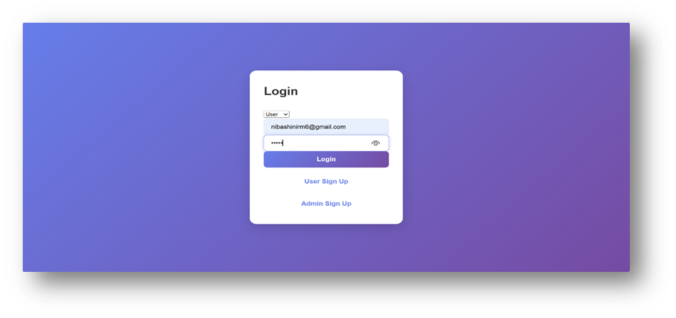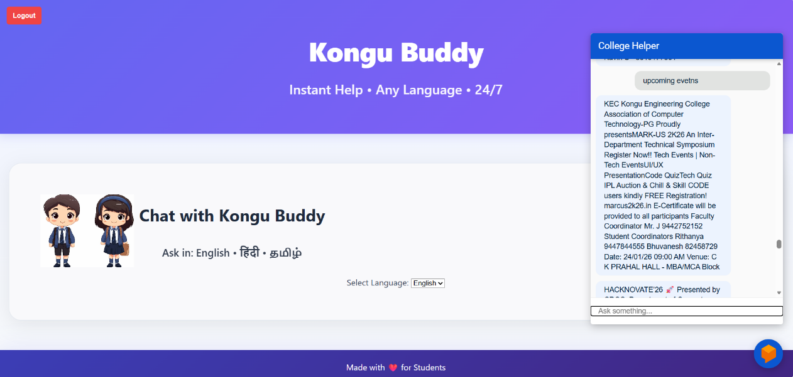
Admin Module
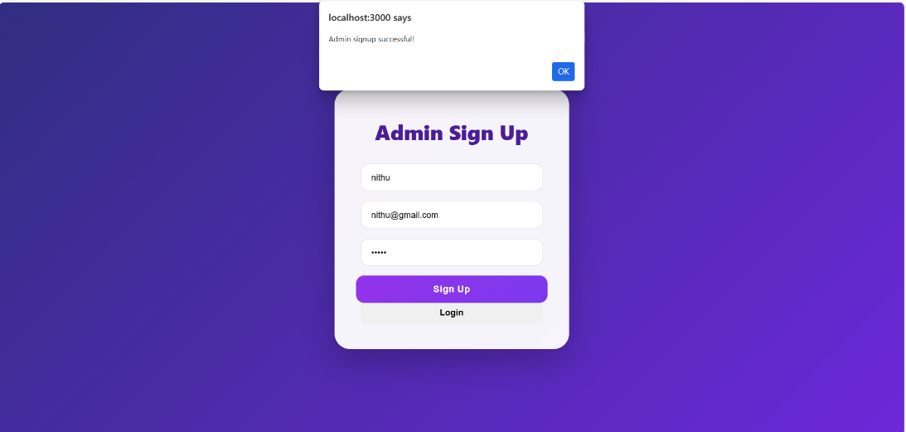
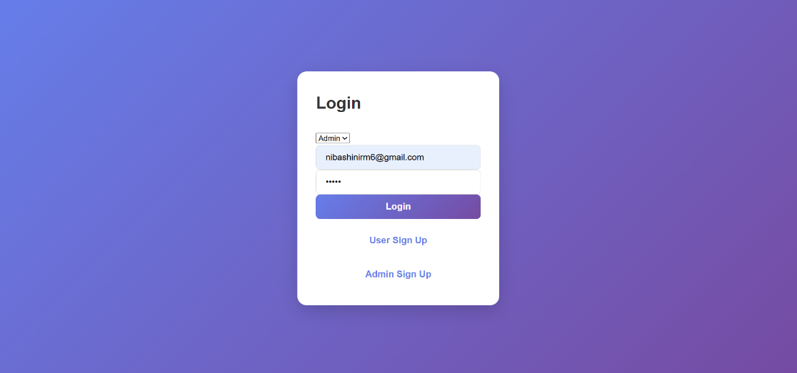
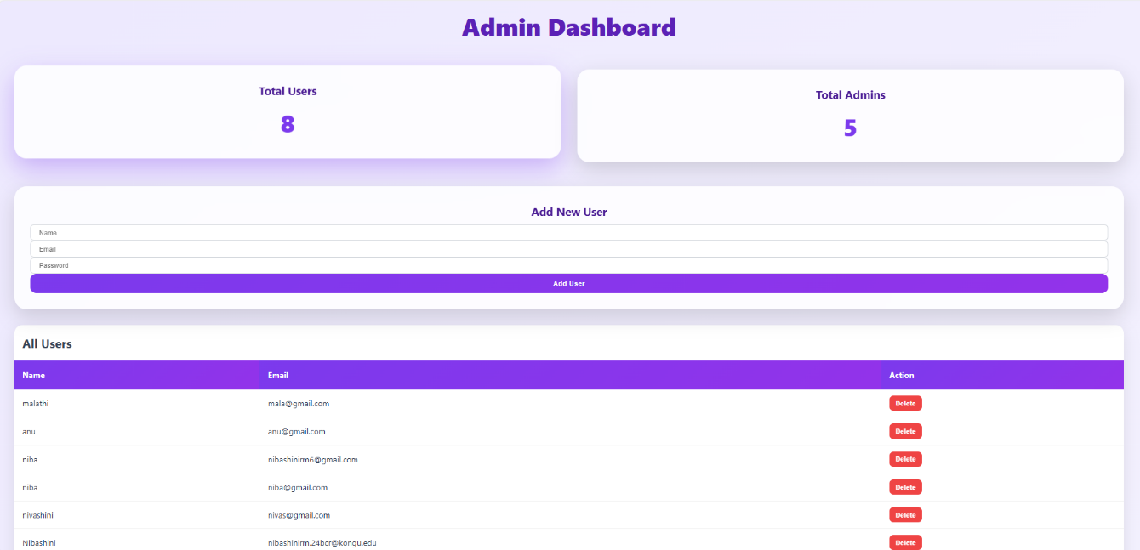

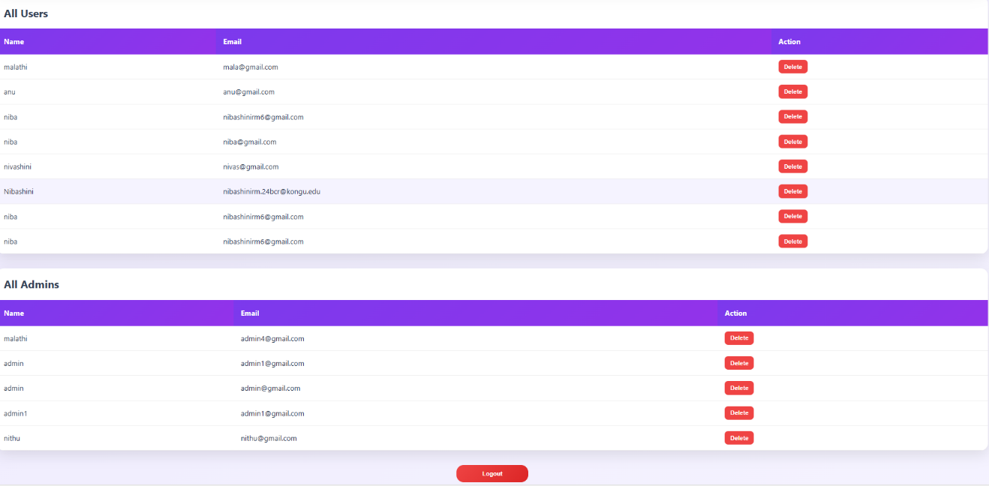

Backend

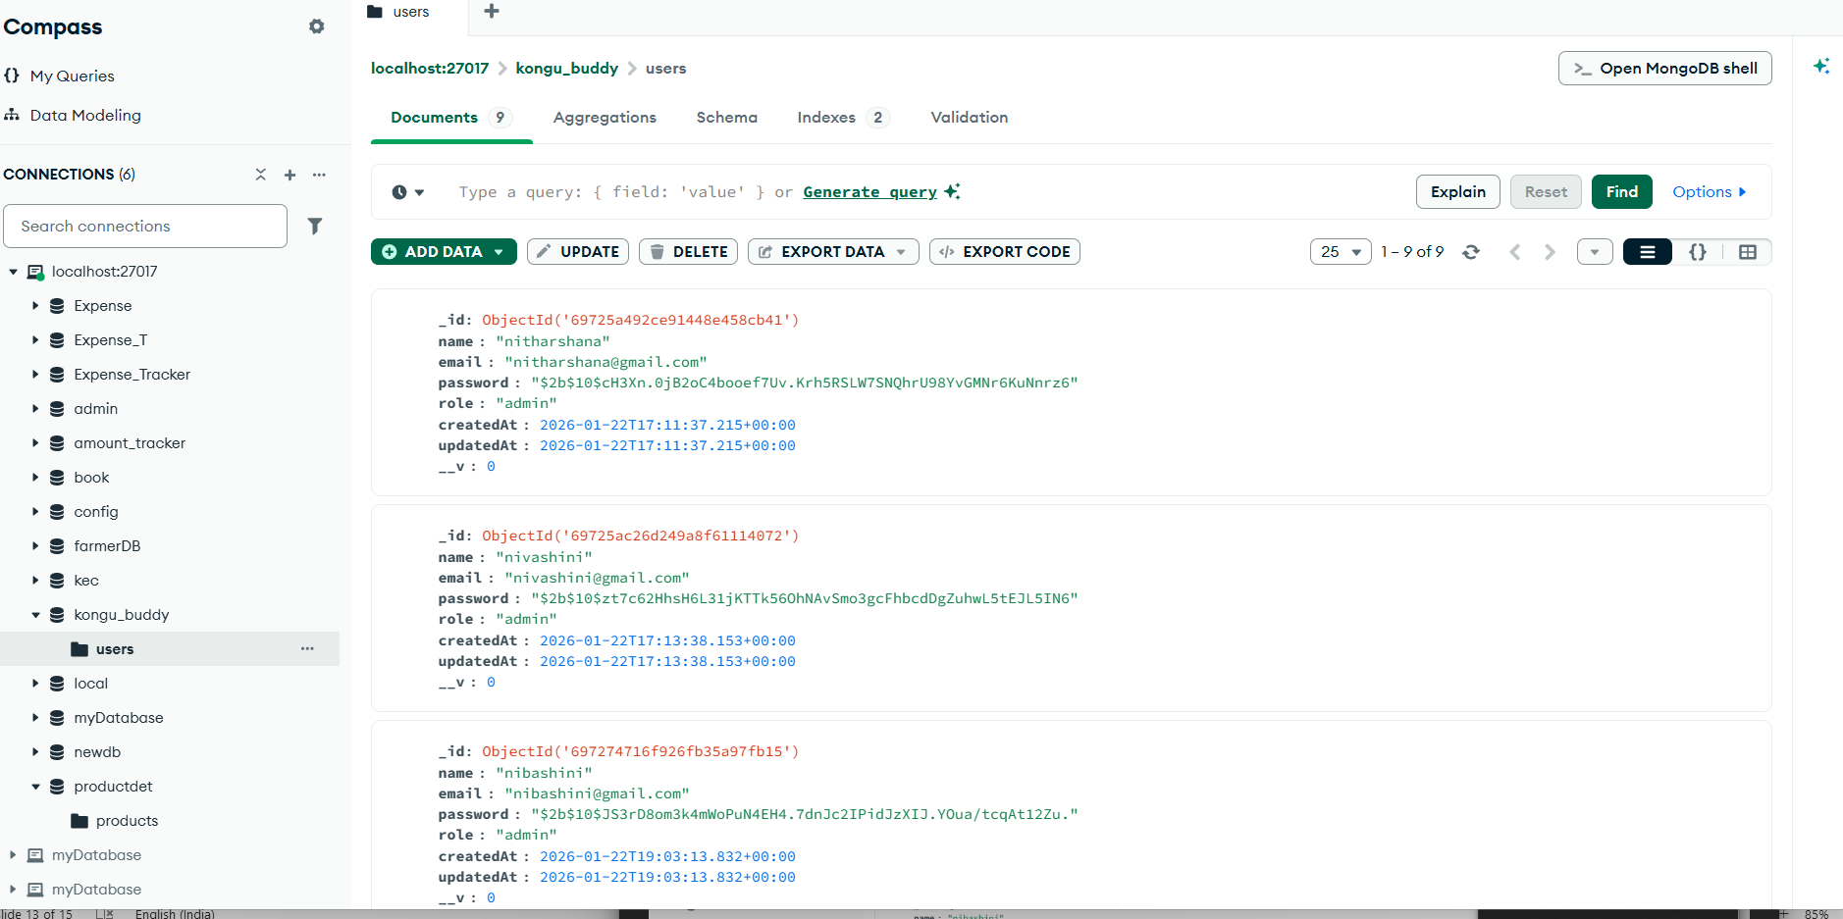

CHAPTER – 7

REFERENCES

- Jurafsky, D., and Martin, J. H., Speech and Language Processing, 3rd Edition, Pearson Education, 2023.
- LeMay, M., Designing Bots: Creating Conversational Experiences, O’Reilly Media, 2018.
- McTear, M., Callejas, Z., and Griol, D., The Conversational Interface: Talking to Smart Devices, Springer, 2016.
- Adamopoulou, E., and Moussiades, L., “An Overview of Chatbot Technology”, Artificial Intelligence Applications and Innovations, Springer, 2020.
- React Official Documentation, Available at: https://react.dev
- JavaScript Tutorials – W3Schools, Available at: https://www.w3schools.com
- Web Development Tutorials – GeeksforGeeks, Available at: https://www.geeksforgeeks.org
- Programming Tutorials – freeCodeCamp, Available at: https://www.freecodecamp.org

